COSEL announces 330% peak power 1kW open-frame power supplies for medical and industrial applications
Press Release
2021-11-16
• 330% peak power for up to 3,000 milliseconds
• EN62477-1 OVC III certified for safety in industrial applications
• Suitable for medical Body Floating (BF) applications
• Small and compact PCB layout optimized for free-air convection
• High efficiency to reduce energy consumption
• 5 year standard warranty
COSEL Co, Ltd (6905: Tokyo) today announced the introduction of 1,000W free-air convection cooling power supplies, the AEA1000F series. With demanding applications in mind, the AEA1000F is able to deliver 330% peak power for a period of up to 3,000 milliseconds. Designed for applications requiring a high level of safety, the AEA1000F is certified according to the EN62477-1 (OVC III) standard for industrial applications and is approved in accordance with ANSI/AAMI ES60601-1, and EN60601-1 3rd Edition for medical applications. The AEA1000F is suitable for Body Floating (BF) applications and complies with 2MOPP (IN/OUT) and 1MOPP (OUT/FG) safety requirement. The AEA1000F layout is optimized for free-air convection making it ideal for use in equipment being operated in low noise environments.
With the ever increasing levels of automation in industrial and medical applications, power supplies must be able to deliver extra power during peak operation times as required by dynamic loads e.g., motor startup. To satisfy and sustain such conditions the power supply must be designed with a high dynamic control level and a power stage able to sustain repetitive peak loads. The AEA1000F is able to deliver 330% of its free-air, convection cooled, nominal power during a period of up to 3,000 milliseconds, which is outstanding and responds to the latest market requirements from industrial and medical equipments.
Industrial applications are now requiring efficient power supplies that are able to work in various environments with a high level of safety. The AEA1000F is certified to the EN62477-1 Over Voltage Category Three (OVC III), meaning that a final equipment powered by the products can be directly connected to the main distribution panel without adding an extra level of isolation. This simplifies the systems designer’s task, reduces costs and guarantees the highest level of efficiency.
For medical applications, the AEA1000F input to output isolation complies with 2MOPP, its input to ground with 1MOPP, and output to ground with 1MOPP making the product suitable for Body Floating (BF) applications. The units are approved in accordance with ANSI/AAMI ES60601-1 and EN60601-1 3rd Edition.
The AEA1000F has an input to output isolation of 4,000VAC, input to ground (FG) of 2,000VAC and output to ground (FG) of 1,500VAC.
Designed for international applications, the versatile AEA1000F has an input voltage of 85 to 264VAC. Three output voltages are available: 24V, 36V and 48V with respective current ratings of 42A, 28A and 21A. Output voltage can be adjusted using a built-in potentiometer.
For low harmonic current distortion, the AEA1000F uses active Power Factor Corrector (PFC), and the switching stage uses an LLC resonant topology deploying the latest generation of power semiconductors, conferring to a typical efficiency of up to 95%.
For additional power the AEA1000F can be connected in parallel, up to six units. When in parallel, by adjusting the output voltage on the ‘Master’ unit, ‘Slaves’ neatly automatically adjust their output voltage to be of equal value.
Optimized for convection cooling, the AEA1000F can be operated within an ambient temperature range of -20 to +70 degree centigrade. Depending on the assembly method and ventilation used in the final equipment, a derating may apply as specified in the technical documentation.
The AEA1000F includes built-in inrush current, overcurrent, overvoltage protection circuits, and thermal protection.
In its open frame format, the AEA1000F measures 50 x 127 x 228.6mm (1.97 x 5 x 9 inches) and weighs 1.5kg max.
The AEA1000F complies with safety requirements: UL (USA), C-UL (Canada), DEMKO (Denmark), and TUV (Germany). The product is UL62368-1, EN62368-1, EN62477-1 (OVC III) certified.
To accommodate application specific requirements, a number of options are available including: Coating (C), Additional cover (N), Vertical positioned screw on a terminal block (T), Terminal block changed to a connector (J), Extended features: Auxiliary outputs (AUX1 12V1A), (AUX2 5V1A), Remote ON/OFF and Alarm (R3), UL508 certification (T5), Over current protection mode changed from hiccup mode to shutdown (P5).
The AEA series is suitable for a large range of applications such as: robots and robotics, infusion-pumps, ventilators, actuators, process control, radio and transmission equipment, and emergency signaling.
The AEA1000F series has a full five-year warranty and conforms to the European RoHS, REACH and Low Voltage Directives.
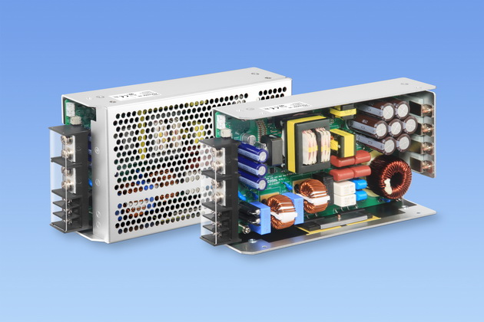
Designed for industrial and medical applications, COSEL’s AEA1000F delivers 330% peak power up to 3,000 milliseconds

Related links:
https://en.cosel.co.jp/product/powersupply/AEA/

About Cosel:
Established in Japan 1969, COSEL is one of the world’s leading designers and manufacturers of high performance AC-DC Power Supplies, DC-DC Converters and EMI Filters. With quality, reliability & flexibility as our main focus, we pride ourselves on developing some of the highest quality and most reliable products seen anywhere in the world today. The Cosel Group is a $250m global company employing some 700 staff with sales offices throughout Japan, Asia, Europe and North America. Our product range is aimed mostly at demanding applications within the Industrial, Factory Automation, Medical, Telecoms, Lighting, Audio/Broadcast & Renewable Energy sectors. A flexible approach with full in-house design means we deliver products using the very latest technology meeting the growing demands of our customers.
Note to the Editors:
The Cosel Group includes the European power specialist Powerbox International AB, which has been acquired June 25, 2018 by COSEL.
For more information contact:
Press and media relations
Patrick Le Fèvre
Phone: +46 (0) 158 703 00

Sales and technical requests
COSEL ASIA LTD.
Rm. 601, 9 Chong Yip Street, Kwun Tong, Kowloon, Hong Kong
http://www.coselasia.com/
Phone: +852-2305-2712
Fax: +852-2305-3006
E-mail: sales@coselasia.com

Reference :
COSEL PR-21:008_AEA1000F_EN

