Entry due: Friday, June 10
Product Category: Wired & Wireless Connectivity (Including IoT & Industrial IoT)
Product Name: LoRa Edge™ LR1120
Product Url: https://www.semtech.com/products/wireless-rf/lora-edge/lr1120
Give a detailed description of your product (100 words or less) 100/100
The LoRa Edge™ LR1120 an ultra-low power chip that allows for direct satellite-connected IoT applications in supply chain management and logistics, with seamless low power geolocation on a global scale. It provides multi band LoRa® and Long Range - Frequency Hopping Spread Spectrum (LR-FHSS) communication over sub-GHz and 2.4GHz Industrial, Scientific and Medical (ISM) bands as well as licensed S-Band for satellites. It integrates a Cloud-native multi-constellation global navigation satellite system scanner and a passive Wi-Fi MAC address scanner, both leveraging Semtech’s LoRa Cloud™ services.
The LR1120 is designed to comply with the physical layer requirements of the LoRaWAN® standard specification released by the LoRa Alliance®, while remaining configurable to meet different application requirements and proprietary protocols.
Why should this product win? (100 words or less)* 100/100
The LR1120 features multi-band capabilities to its leading LoRa Edge™ device-to-Cloud geolocation platform. With this, the LR1120 enables direct satellite-connected IoT applications for precise and low power location services on a massive, global scale.
Targeted to support organizations by improving operational efficiencies and financials while meeting ESG goals, the LR1120 offers two key advantages. First is ultra-low power trackers that are interoperable, enabling global logistics companies a universal connectivity to mitigate regulatory and deployment challenges. Furthermore, the platform unfolds countless use cases for remote locations such as infrastructure management to agriculture and environmental monitoring that are historically costly and complex.
Product Image:
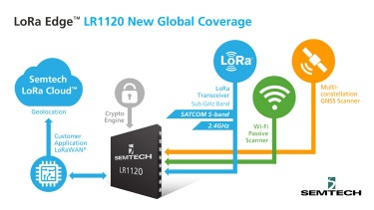
Product Data Sheet: https://semtech.my.salesforce.com/sfc/p/#E0000000JelG/a/2R000000UtfN/JfkkoV9lY3JJ8xv_raCod7qyg5ozj5Pf9Zg5.BzuvcQ
Conference: Embedded World

