Powerbox’s 1200W power supply has adjustable ‘near to zero’ output voltage and current for conduction cooling applications

Press Release

March 29, 2022
Powerbox, one of Europe’s largest power supply companies, and for more than four decades a leading force in optimizing power solutions for demanding applications, has announced the release of the 1200W rated OFI1200A AC/DC power supply for industrial applications. Optimized for conduction cooling, the OFI1200A delivers high performance levels across a baseplate temperature range of -40 to +95 degrees C without the use of a fan. The power supply operates with a wide universal input range from 85 to 305VAC with power factor correction (PFC). Covering a large range of applications, its output voltage and current can be adjusted from near zero to the maximum allowed for each model.
A number of industrial applications require power supplies to operate with limited or no ventilation cooling. In this respect, those operating in harsh environments where electronic equipment is installed in a sealed box, radio communication systems subject to adverse weather conditions, outdoor displays and traffic signaling, and indoor equipment with very strict audible noise restrictions. In addition to environmental requirements, reliability and cost of maintenance are motivating systems designers not to use fans and blowers.
Conduction cooling requires very specific building practices and the PRBX OFI1200A has been designed to guarantee optimal heat transfer from the dissipating components to the baseplate, delivering a high level of performance within an operating temperature of -40 to +95 degree centigrade at baseplate. Depending on the assembly method and the overall cooling conditions, a derating may apply as specified in the technical documentation.
To cover a large range of applications, the OFI1200A operates with a wide universal input range from 85 to 305VAC (Nominal 100 to 277VAC). The unit includes a PFC with a coefficient of 0.98/0.95 (110VAC/230VAC).
The OFI1200A is available in three versions of single output DC voltage, 12V/84A ; 28V/43A and 48V/25A. Using a high efficiency topology, the typical efficiency for the 48V output unit at 230VAC input is an excellent 92%.
Industrial applications such as professional lighting or even low-power electrolyzers require the power supply to deliver constant current, and this must be easily adjustable. Often such equipments are operated in environments requiring the electronics to be enclosed and protected from hazards. This necessitates the power supply to offer an external control to adjust the output voltage and/or current from the maximum allowed to near zero.
To make it possible for customers to precisely adjust the voltage and current to their application, the OFI1200A offers two analog inputs, VTRM and ITRM. Using those functions, the output voltage and current can be adjusted from near zero up to the maximum specified per model. For example, the 28V output can be adjusted from near zero volts up to 33.6V, and the output current from near zero amps up to 43A. The output voltage can also be adjusted using the provided onboard potentiometer.
The extended trimming and control function simplifies the utilization of the power supply in constant voltage (CV) or constant current (CC) mode, without adding external circuitry.
For applications requiring redundancy or higher power, it is possible to connect up to nine units in parallel, delivering an impressive total power level of up to 9,720W in conduction cooling mode. To maintain the highest level of efficiency when operated in parallel or in redundancy-mode, optional active ORing circuitry deploying high performance FET technology (Option-O) is available on the OFI1200A28 and OFI1200A48.
For safety, the OFI1200A has an IN/OUT isolation of 3,000VAC and IN/FG of 2,000VAC. Output isolation to FG is 500VAC. The power supply includes over current protection with auto recovery, over voltage and over temperature protection.
The OFI1200A board includes easy access to auxiliary functions via on board connectors, namely: Remote Control, Output Voltage Sensing, Power Good, VTRM, ITRM.
The OFI1200A has passed shock and vibration testing as specified in MIL-STD-810H. In that respect the products have been tested to levels far above normal operating conditions and are designed to sustain high, 20G level shocks.
In its open frame format, the OFI1200A measures 142 x 39 x 260mm (5.59 x 1.54 x 10.36 inches) and weighs 1.2kg max. An optional metal cover is available, adding just 1mm to the height and 200 grams to the weight (Option-N).
Benefiting from a design optimized for conduction cooling, the OFI1200A is suitable for applications requiring a silent power solution such as in a control room. Equally, it is suitable for industrial applications when forced air ventilation is not possible due to environmental constraints. Attached to a chassis or cold plate, the OFI1200A can deliver impressive power levels with a high level of reliability.
The OFI1200A is certified in accordance with UL62368-1 3rd edition, cUL (equivalent to CAN/CSA-C22.2 No.62368-1).
The OFI1200A series has a full three-year warranty and conforms to the European RoHS, REACH and Low Voltage Directives. The product carries the CE, UKCA and cURus markings.

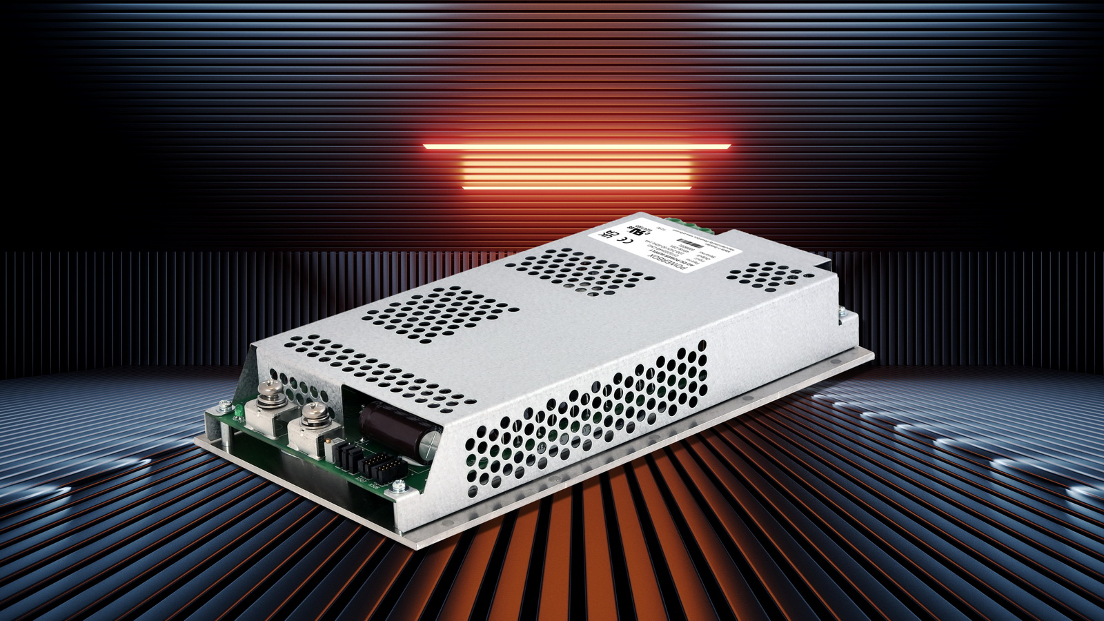
Powerbox’s new 1200W OFI1200A power supply is optimized for conduction cooling as required by demanding industrial applications

Related links:
PRBX OFI1200A
https://www.prbx.com/product/ofi1200a/

About Powerbox (PRBX):
Founded in 1974, with headquarters in Sweden and operations in 15 countries across four continents, Powerbox serves customers all around the globe. The company focuses on four major markets - industrial, medical, transportation/railway and defense - for which it designs and markets premium quality power conversion systems for demanding applications. Powerbox’s mission is to use its expertise to increase customers’ competitiveness by meeting all of their power needs. Every aspect of the company’s business is focused on that goal, from the design of advanced components that go into products, through to high levels of customer service. Powerbox is recognized for technical innovations that reduce energy consumption and its ability to manage full product lifecycles while minimizing environmental impact. Powerbox is a Cosel Group Company.
For more information
Visit www.prbx.com
Please contact Patrick Le Fèvre, Chief Marketing and Communications Officer
+46 (0) 158 703 00
marcom@prbx.com
Reference:
PRBX-PR-2201-EN

