Socionext SC1233AR3 - 24GHz 2D Radar Sensor
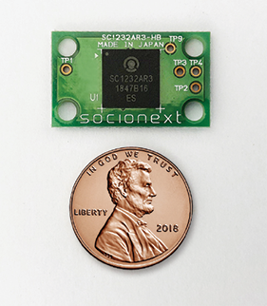

Example use case
Entry Motion/ Presence Detection
The internal processing engine calculates & outputs the Motion Detection (Entry Motion / Presence Detection) result through a DETOUT pin.
Entry Motion Detection
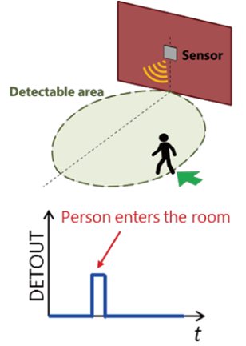

Presence Detection
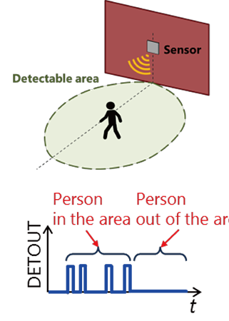
Distance Detection
The internal processing engine calculates & outputs the distance to the moving objects through I2C or SPI.
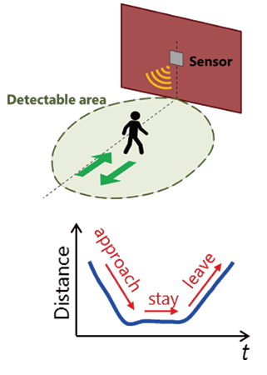

Angle Detection
Angle of the detected object can be calculated in the ext. MCU and be used for sector-level detection.

