Socionext SC1702 Smart Display Controller for Automotive Applications

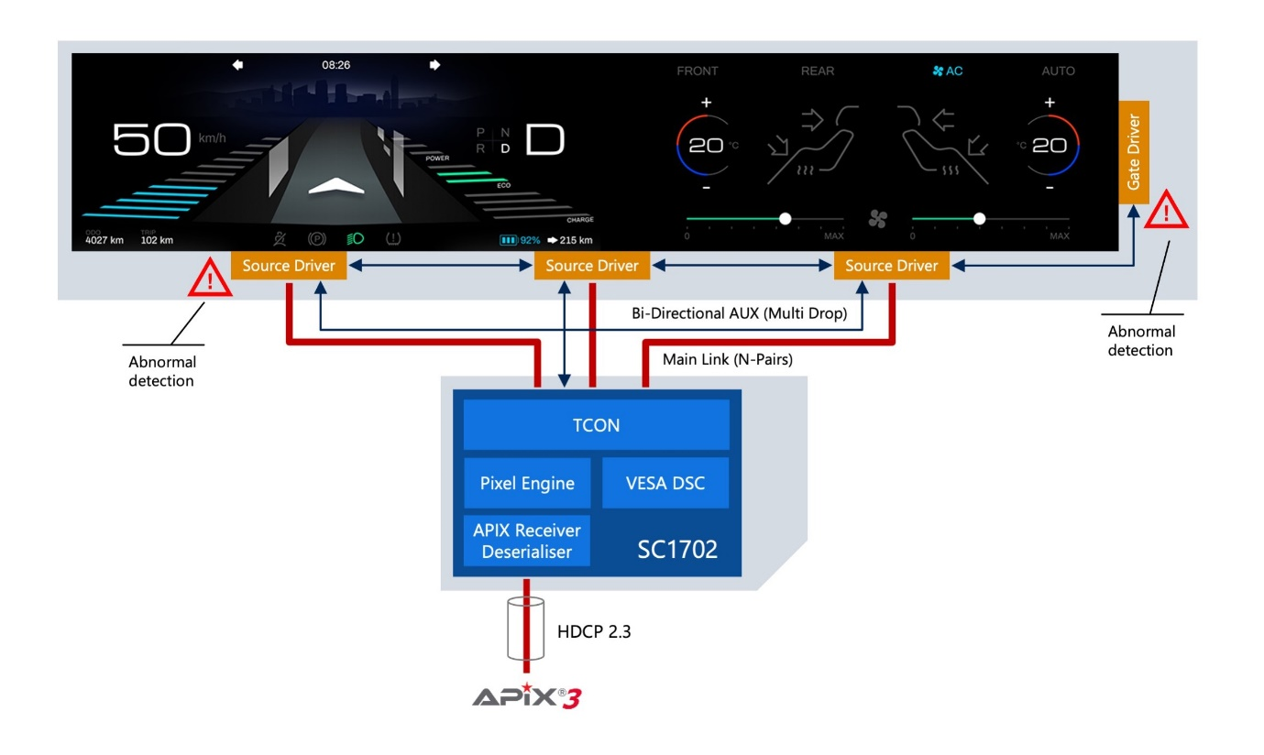

link to video: https://www.eu.socionext.com/company/videos/sc1701-2-from-socionext.html

